**Shre e Swa mina ra ya n College of Computer Science**



**Sardarnagar, Bhavnagar.**

**(Affiliated to M. K. Bhavnagar Univers ity)**

|  |  |
| --- | --- |
| **Progress Report Number:** | 1 |
| **Project Title** | Master Budget |
| **Project Guide** | Mr. Nirav Shah |

|  |  |
| --- | --- |
| **Roll No.** | **Name of Student** |
| 0122058 | Mr. Vinay Dodiya |
|  |  |
|  |  |

|  |  |
| --- | --- |
| **Progress Report Number:** | 1 |
| **Project Title** | Master Budget |
| **Project Guide** | Mr. Nirav Shah |

|  |  |
| --- | --- |
| **Submission Date** |  |
| **Signature of Students** |  |
|  |
|  |
| **Signature of Guide** |  |

1. **DATA DICTIONARY and ER DIAGRAM**
   1. **DATA DICTIONARY**

* Data Dictionary is representing the details of Table which are available in the System. Here some Tables which are designed in the Database.

1. **Table:** Accounts

|  |  |  |  |  |  |
| --- | --- | --- | --- | --- | --- |
| **Sr. no.** | **Field Name** | **Type** | **Size** | **Constraints** | **Description** |
| 1 | Name | Varchar | 20 | Not Null | Name of User |
| 2 | Email | Varchar | 30 | Primary Key | Email ID of User |
| 3 | Country | Varchar | 20 | Not Null | Country of User  (Reference Currency (Country_name)) |
| 4 | Password | Varchar | 20 | Not Null | Password for Login |

1. **Table:** Bank_details

|  |  |  |  |  |  |
| --- | --- | --- | --- | --- | --- |
| **Sr. no.** | **Field Name** | **Type** | **Size** | **Constraints** | **Description** |
| 1 | bankName | Varchar | 20 | Not Null | Name of Bank |
| 2 | accountNo | Varchar | 11 | Not Null | Account Number |
| 3 | ifscCode | Varchar | 11 | Not Null | IFSC Code of Bank Branch |
| 4 | email | Varchar | 30 | Not Null | Email id of User  (Reference Account (Email)) |
| 5 | PhoneNo | Char | 10 | Not Null | Phone Number |
| 6 | branch | Varchar | 20 | Not Null | Name of Bank Branch |
| 7 | Pincode | Char | 6 | Not Null | Pincode of Branch |
| 8 | date | Datetime | - | - | Date |

1. **Table:** Category

|  |  |  |  |  |  |
| --- | --- | --- | --- | --- | --- |
| **Sr. no.** | **Field Name** | **Type** | **Size** | **Constraints** | **Description** |
| 1 | category_ID | int | 11 | Primary Key | Category ID |
| 2 | accountNo | Varchar | 11 | Not Null | Account Number  (Reference Bank_details (accountNo)) |
| 3 | category_name | Varchar | 20 | Not Null | Name of Category |
| 4 | type | Varchar | 10 | Not Null | Category type (Income / Expense) |
| 5 | date | datetime | - | - | Date |

1. **Table:** Currency

|  |  |  |  |  |  |
| --- | --- | --- | --- | --- | --- |
| **Sr. no.** | **Field Name** | **Type** | **Size** | **Constraints** | **Description** |
| 1 | country_id | Int | 3 | Primary Key | Country ID |
| 2 | Country_name | Varchar | 20 | Not Null | Country Name |
| 3 | currency | Varchar | 30 | Not Null | Name of Currency |
| 4 | Symbol | Varchar | 10 | Not Null | Symbol of Currency |
| 5 | crvalue | Double | - | - | Currency in US Dollar like (1 USD = 86.03 INR) |

1. **Table:** Transactions

|  |  |  |  |  |  |
| --- | --- | --- | --- | --- | --- |
| **Sr. no.** | **Field Name** | **Type** | **Size** | **Constraints** | **Description** |
| 1 | account | Varchar | 20 | Not Null | Account Number  (Reference Account (accountNo)) |
| 2 | tran_id | Double | - | Primary Key | Transaction ID |
| 3 | tranname | Varchar | 20 | Not Null | Transaction Name |
| 4 | category | Varchar | 20 | Not Null | Category of Transaction  (Reference Category (category_name)) |
| 5 | tran_date | date | - | - | Transaction date |
| 6 | type | Varchar | 20 | Not Null | Transaction Type (Income / Expense) |
| 7 | method | Varchar | 20 | Not Null | Payment Method |
| 8 | amount | double | - | - | Transaction Amount |
| 9 | memo | Text | - | - | Description of Transaction |
| 10 | date | datetime | - | - | Current time when transaction perform |

1. **Table:** Income

|  |  |  |  |  |  |
| --- | --- | --- | --- | --- | --- |
| **Sr. no.** | **Field Name** | **Type** | **Size** | **Constraints** | **Description** |
| 1 | account | Varchar | 20 | Not Null | Account Number  (Reference Account (accountNo)) |
| 2 | tran_id | Double | - | Primary Key | Transaction ID |
| 3 | tranname | Varchar | 20 | Not Null | Transaction Name |
| 4 | category | Varchar | 20 | Not Null | Category of Transaction  (Reference Category (category_name)) |
| 5 | type | Varchar | 20 | Not Null | Transaction Type (Income / Expense) |
| 6 | method | Varchar | 20 | Not Null | Payment Method |
| 7 | tran_date | date | - | - | Transaction date |
| 8 | amount | double | - | - | Transaction Amount |
| 9 | balance | double | - | - | Balance |

1. **Table:** Expense

|  |  |  |  |  |  |
| --- | --- | --- | --- | --- | --- |
| **Sr. no.** | **Field Name** | **Type** | **Size** | **Constraints** | **Description** |
| 1 | account | Varchar | 20 | Not Null | Account Number  (Reference Account (accountNo)) |
| 2 | tran_id | Double | - | Primary Key | Transaction ID |
| 3 | tranname | Varchar | 20 | Not Null | Transaction Name |
| 4 | category | Varchar | 20 | Not Null | Category of Transaction  (Reference Category (category_name)) |
| 5 | type | Varchar | 20 | Not Null | Transaction Type (Income / Expense) |
| 6 | method | Varchar | 20 | Not Null | Payment Method |
| 7 | tran_date | date | - | - | Transaction date |
| 8 | amount | double | - | - | Transaction Amount |
| 9 | balance | double | - | - | Balance |

* 1. **ER DIAGRAM**
* An ER (Entity-Relationship) diagram is a visual representation of the entities (objects, concepts, or things) in a system and the relationships between them. It is often used in database design to help structure data and its interactions.

Here’s an overview of the components in an ER diagram:

* **Entities**: These are objects or concepts that have data stored about them.
* **Attributes**: These are the properties or details that describe an entity.
* **Relationships**: These represent the associations between entities.
* **Primary Key**: This is an attribute that uniquely identifies an entity.
* **Foreign Key**: An attribute in one entity that links it to another entity, establishing a relationship.
* **Cardinality**: This describes the number of instances of one entity related to the number of instances of another entity (One-to-One, One-to-Many, Many-to-Many, Many-to-One).

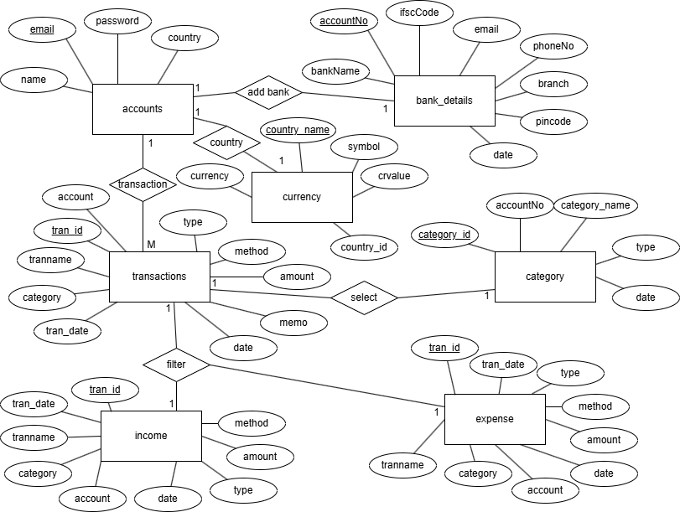

1. **SCREEN LAYOUT**

* Here some Screen Layout which are use into the System**.**
* Index Page
* Login Page
* Sign Up Page
* Forget Password Page
  1. **Login Page**

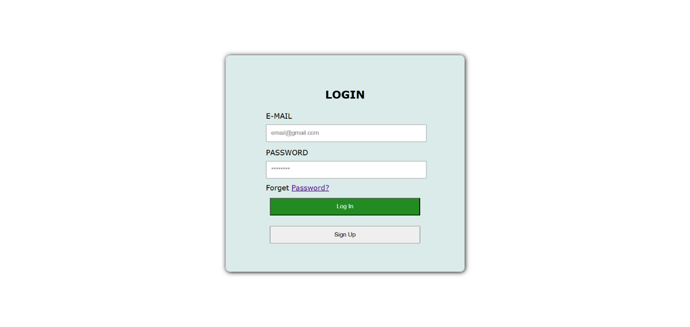

* 1. **Sign Up Page**

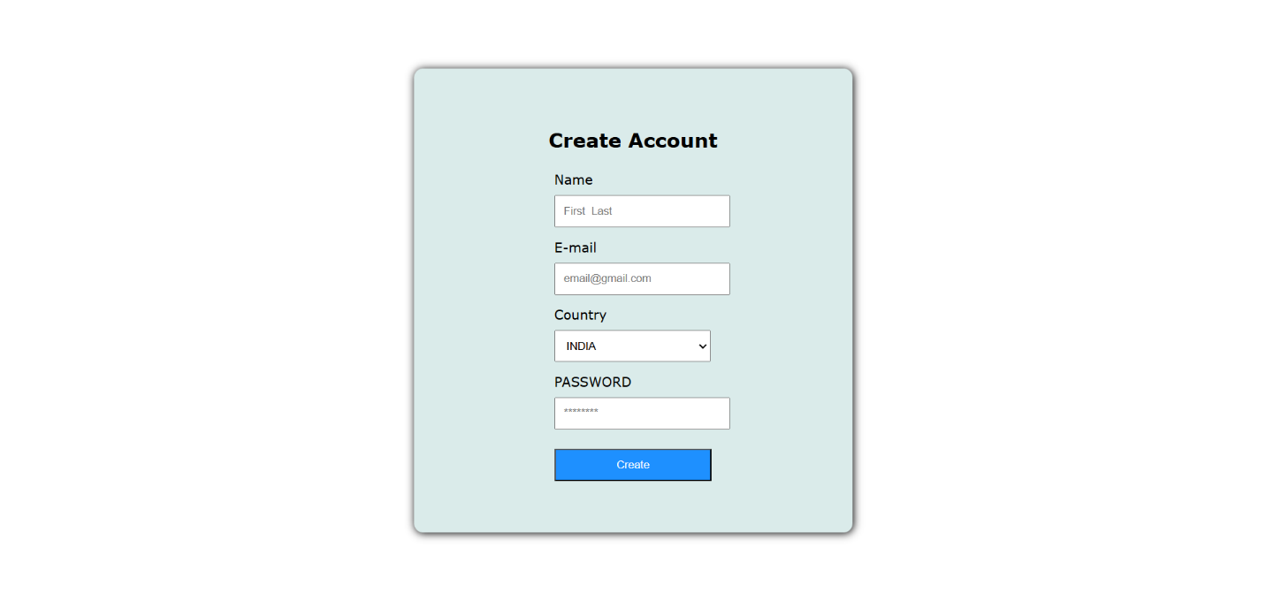

* 1. **Forget Password Page**

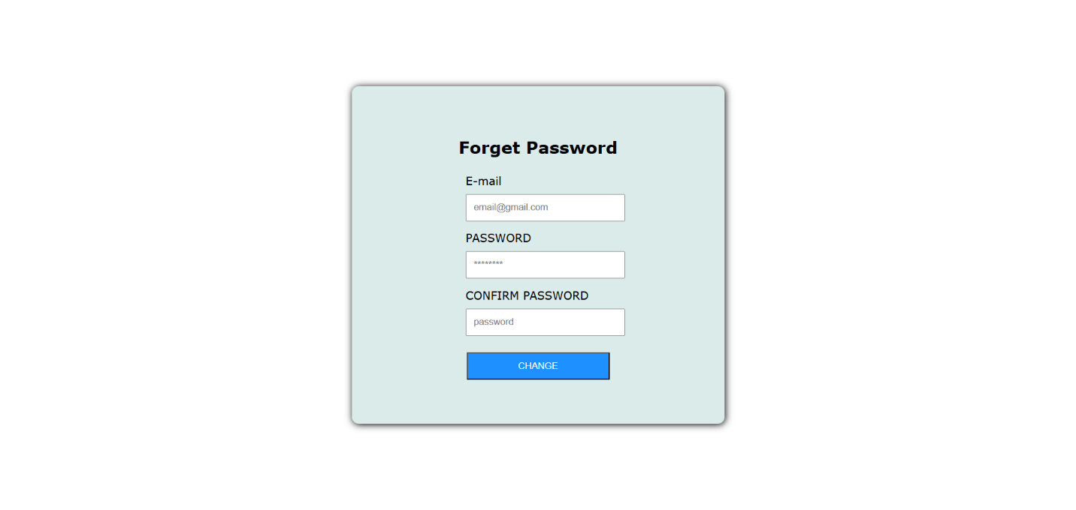

* 1. **Index Page**